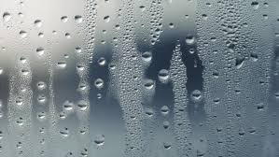
Moisture overload? Dehumidify!
In an attempt to conserve energy, homes are increasingly being constructed more and more airtight. Storm windows, insulation, caulking and filling cracks with weather stripping are just a few ways that homeowners strive to save energy—unfortunately, all of these techniques also make it more difficult for heating and cooling systems to remove excess humidity…no matter how new the technology.
Why Is It Necessary To Eliminate Excess Humidity?
The bottom line is that it causes your indoor air to feel more uncomfortable than it should, not to mention the health risks that come along with a damp home environment.
Managing the humidity level of your home, however, can give you greater comfort and improved indoor air quality!
The ideal level of humidity in your home is 45%. Although it’s difficult to maintain such consistent level all of the time, working to keep humidity as close to 45% as possible will not only make your home FEEL more comfortable, but will transform it from the environment where mold, mildew and bacteria can thrive.

Financial Benefits of aWhole Home Dehumidifier
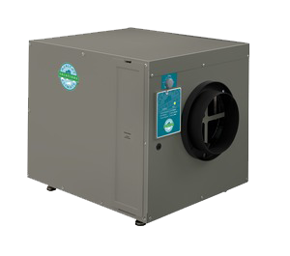
While shopping through your local Target or Walmart you’ve probably seen portable dehumidifiers—these are great for a small spaces, such as a child’s room, but when you need to dehumidify your entire home, you need a whole home dehumidifier!
During the summer months, your home’s humidity levels will naturally soar! Most homeowners resort to lowering their thermostats to escape the muggy heat, increasing their utility bills. A better solution is a whole home dehumidifier! The dehumidifier will work to eliminate that clammy feeling without having to lower your home’s overall temperature. Imagine a cooler home without touching the thermostat! Using your cooling system LESS means saving MORE!
Does Your Home Need A Dehumidifier?
You might not even realize your home is falling prey to excessive humidity! Take a look at these telltale indicators of an overly humid home environment!
    - Mold Spots—one of the easiest signs to see are mold spots. They are a #1 indicator of excessive humidity. This is a dangerous problem and can spread quickly, causing health issues and decreasing the value of your home.
    - Condensation Buildup—if you notice that the windows of your home are covered with beads of water, or a vapor-like fog on the glass, you have a room with too much moisture. Your home’s humidity is working overtime!
    - Musty Odors—a old or musty smell in your home almost always means that mildew and mold are present. These contaminants thrive on moisture, which starts to collect in areas like basements, garages and crawlspaces.
    - Water Damage Stains—water stains along your walls and ceilings are a sign of excess moisture. Be sure to have a professional inspect water stains to be sure you don’t have pipe leakage. If you see the damage, the water is already present and a dehumidifier will help begin the drying-up process!
    - Rotting or Buckling Wood—wood retains moisture and with an overload it will begin to buckle and rot. Rotting wood attracts unwanted pests like termites, and the damage can be cosmetic, causing you to consider expensive remodeling.
- Allergies—allergy prone homeowners will notice significant increase in allergy troubles due to their indoor air quality. Excess moisture in the air breeds airborne allergens like dust mites and mold spores. If your allergies act up while you’re inside, you likely are experiencing a poor indoor air quality. Humidity levels can also cause simple discomforts like chapped lips, and more serious issues like respiratory breathing problems.

